# Data Structures

* A **data structure** is a particular way of organizing data in a computer so that it can be used effectively.
* For example, we can store a list of items having the same data-type using the *array* data structure.



# **Essentials in algorithms and data structures**

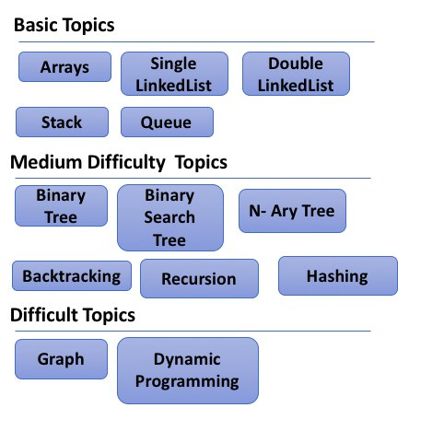 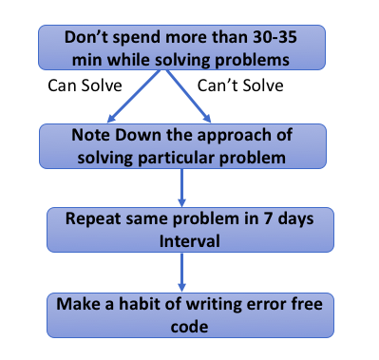

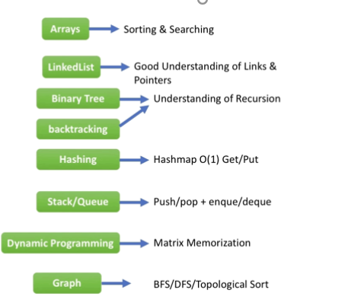

* Sorting: [bubble sort](https://en.wikipedia.org/wiki/Bubble_sort), [quicksort](https://en.wikipedia.org/wiki/Quicksort), [merge sort](https://en.wikipedia.org/wiki/Merge_sort)
* Search: [linear search](https://en.wikipedia.org/wiki/Linear_search), [binary search](https://en.wikipedia.org/wiki/Binary_search_algorithm)
* Data structures: [linked list](https://en.wikipedia.org/wiki/Linked_list), [hash table](https://en.wikipedia.org/wiki/Hash_table), [array](https://en.wikipedia.org/wiki/Array_data_structure), [tree](https://en.wikipedia.org/wiki/Tree_(data_structure)), [binary search tree](https://en.wikipedia.org/wiki/Binary_search_tree), [stack](https://en.wikipedia.org/wiki/Stack_(abstract_data_type)), [queue](https://en.wikipedia.org/wiki/Queue_(abstract_data_type))
* Consider reviewing common algorithms such as traversals, divide and conquer, breadth-first search vs. depth-first search and understand the tradeoffs for each.

# [**Which algorithms/data structures should I "recognize" and know by name?**](https://softwareengineering.stackexchange.com/questions/155639/which-algorithms-data-structures-should-i-recognize-and-know-by-name)

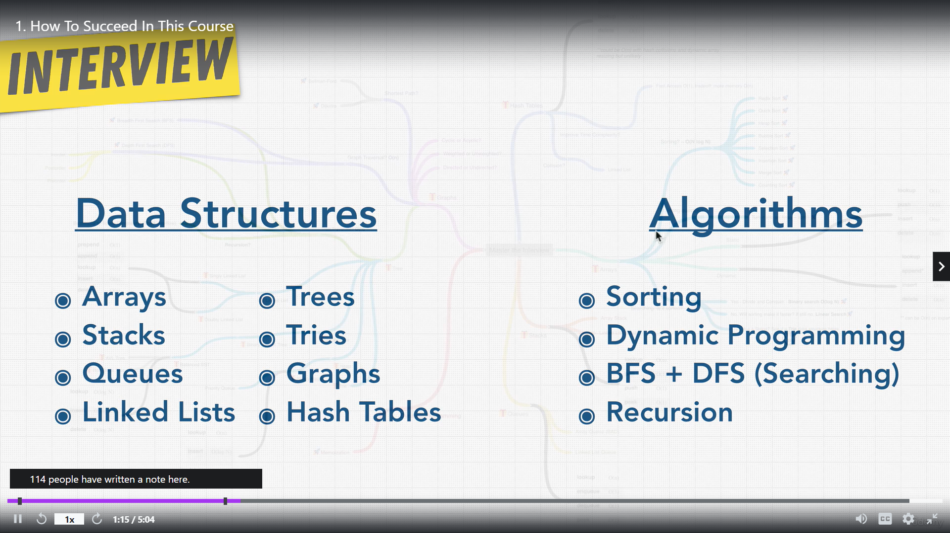

### **Data Structures**

* Machine Data Representation
  + Ones, Two's Complement, and Related Arithmetic
  + Words, Pointers, Floating Point
  + Bit Access, Shifting, and Manipulation
* Linked Lists
* Hash Tables (maps or dictionaries)
* Arrays
* Trees
* Stacks
* Queues
* Graphs
* Databases

### **Algorithms**

* Sorting:
  + Bubble Sort (to know why it's bad)
  + Insertion Sort
  + **Merge Sort – important as per logicmojo.com 98 % used – Worst time complexity – O(log n)**
  + Quick Sort
  + Radix style sorts, Counting Sort and Bucket Sort
  + Heap Sort * Count sort– 2nd best as per logicmojo.com
  + Bogo and Quantum Sort (=
* Searching:
  + Linear Search
  + Binary Search
    - * 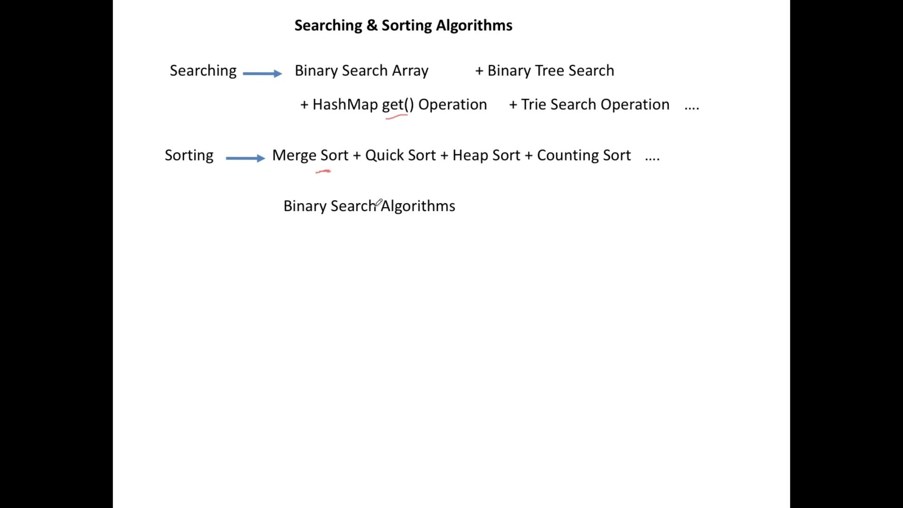
      * 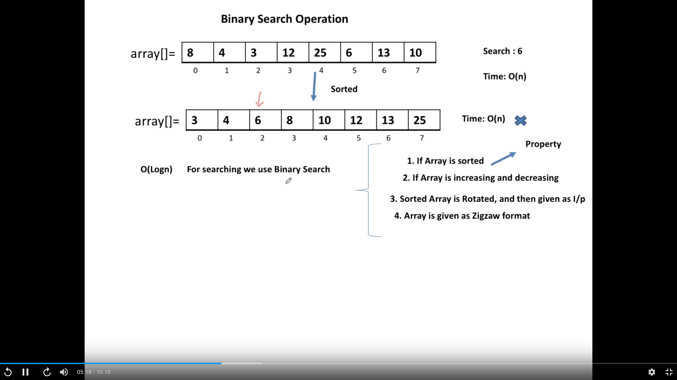
      * 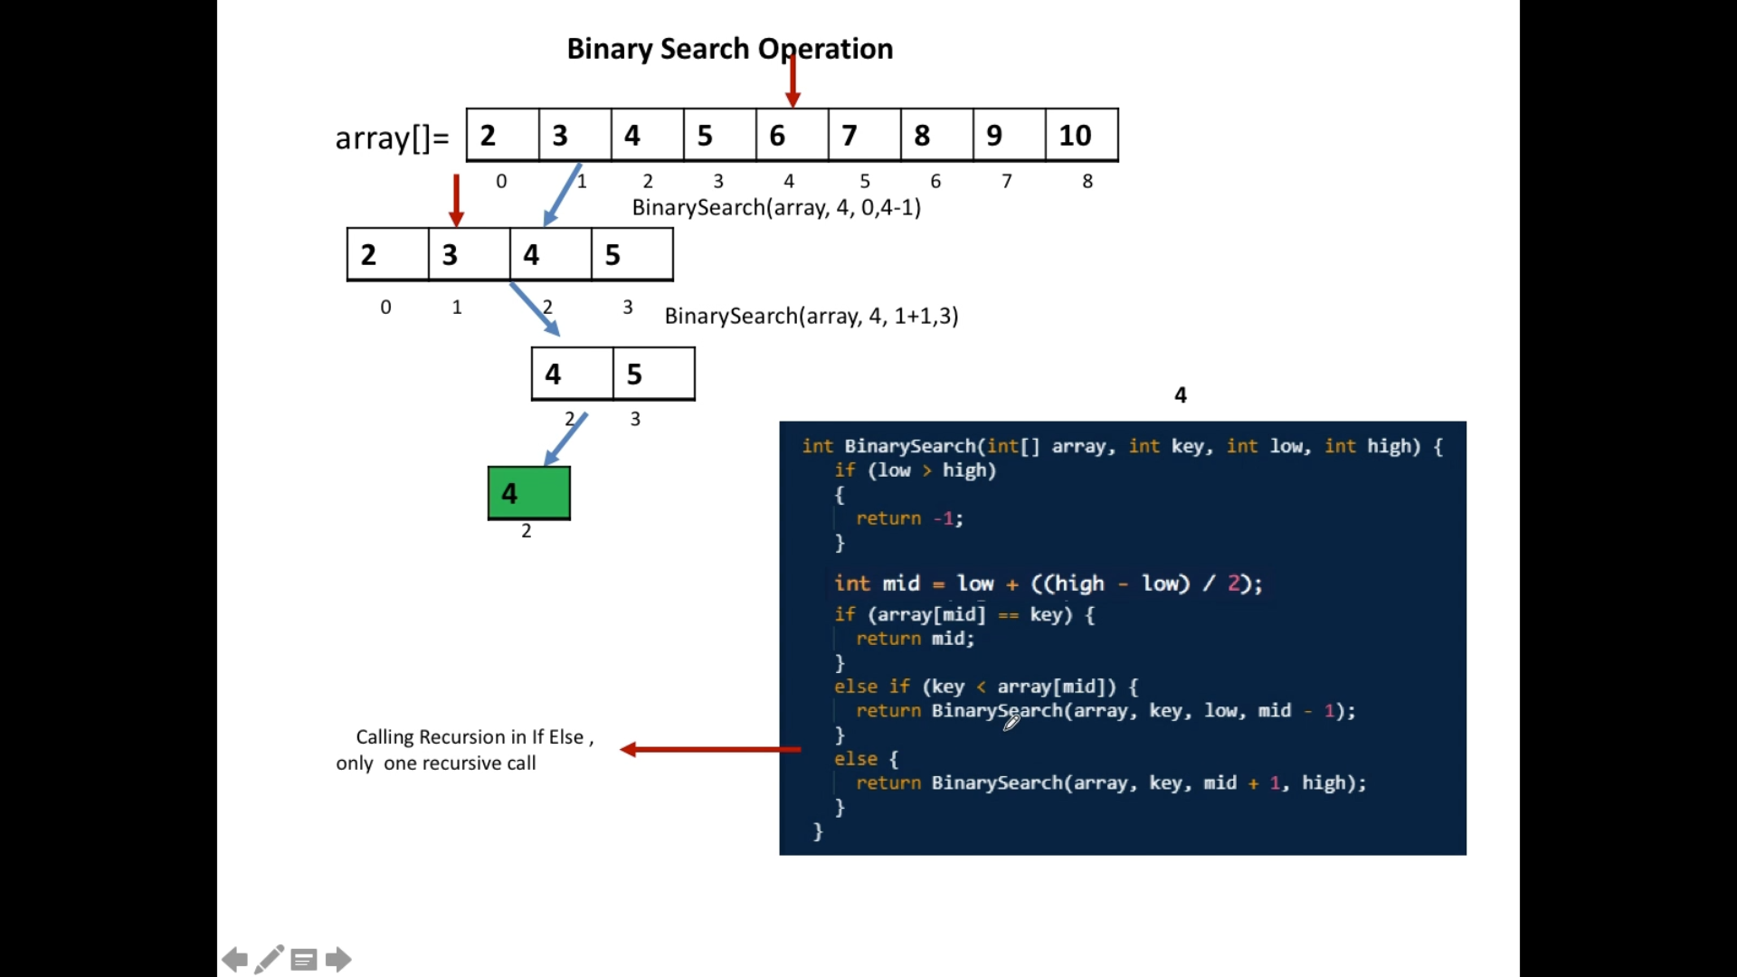
  + Depth First Search
  + Breadth First Search
* String Manipulation
* Iteration
* Tree Traversal
* List Traversal
* Hashing Functions
* Concrete implementation of a Hash Table, Tree, List, Stack, Queue, Array, and Set or Collection
* Scheduling Algorithms
* File System Traversal and Manipulation (on the inode or equivalent level).

### **Design Patterns**

* Modularization
* Factory
* Builder
* Singleton
* Adapter
* Decorator
* Flyweight
* Observer
* Iterator
* State [Machine]
* Model View Controller
* Threading and Parallel Programming Patterns

### **Paradigms**

* Imperative
* Object Oriented
* Functional
* Declarative
* Static and Dynamic Programming
* Data Markup

### **Complexity Theory**

* Complexity Spaces
* Computability
* Regular, Context Free, and Universal Turing Machine complete Languages
* Regular Expressions
* Counting and Basic Combinatorics

## **Beyond**

To get into what you're asking about later in your question, if you are familiar with the above, you should be easily able to identify the appropriate pattern, algorithm, and data structure for a given scenario. However, you should recognize that there is often no best solution. Sometimes you may be required to pick the lesser of two evils or even simply choose between two equally viable solutions. Because of this, you need the general knowledge to be able to defend your choice against your peers.

Here are some tips for algorithms and data structures:

* Binary Search can only (and should) be used on **sorted data**.
* Radix style sorts are awesome, but only when you have finite classes of things being sorted.
* Trees are good for almost anything as are Hash Tables. The functionality of a Hash Table can be extrapolated and used to solve many problems at the cost of efficiency.
* Arrays can be used to back most higher level data structures. Sometimes a "data structure" is no more than some clever math for accessing locations in an array.
* The choice of language can be the difference between pulling your hair out over, or sailing through, a problem.
* The ASCII table and a 128 element array form an implicit hash table (=
* Regular expressions can solve a lot of problems, but they [can't be used to parse HTML](https://stackoverflow.com/questions/1732348/regex-match-open-tags-except-xhtml-self-contained-tags).
* Sometimes the data structure is just as important as the algorithm.

# Interview preparation

1. <https://www.geeksforgeeks.org/must-do-coding-questions-for-product-based-companies/>
2. <https://sobit.me/2016/07/08/amazon-software-engineer-interview/>
3. <https://en.wikipedia.org/wiki/Situation,_task,_action,_result>
4. <https://www.amazon.jobs/en/landing_pages/interviewing-at-amazon#onlineapp>
5. <https://www.amazon.jobs/en/landing_pages/in-person-interview>
6. <https://awssdeinterviewprep.splashthat.com/>
7. <http://bigocheatsheet.com>

# AWS Recommendation

## **Algorithms**

1. Mostly binary search, sort.
2. Be able to traverse a binary tree in every way thinkable. Depth-first traversal. In-place/ in-order With recursion, without recursion
3. Know search algorithms to find certain characters in a string, sort algorithms to reverse certain characters in a string.
4. Really know how to implement a DFS/ BFS properly

**Data Structures:**

1. Know the performance pros and cons, tradeoffs of hashing (hashmaps/ hashtables)
2. know what a heap is, be able to turn a doubly linked list into a binary, lists, set, tables, trees, etc.
3. Know your collection libraries, language-specific libraries for data structures. (ie for Java - know the collection libraries in Guava. Know basic streams, the I/O). Basically be able to do data structures that contain other data structures
4. See links below for DS you should be familiar with:
   1. [Array/Vector](https://en.wikibooks.org/wiki/Data_Structures/Arrays)
   2. [Linked Lists](https://en.wikibooks.org/wiki/Data_Structures/List_Structures)
   3. [Trees](https://en.wikibooks.org/wiki/Data_Structures/Trees)(Tree, Binary Tree, Binary Search Tree, Red-Black Tree, etc.)
   4. [Heaps](https://en.wikibooks.org/wiki/Data_Structures/Min_and_Max_Heaps)
   5. [Hash Table](https://en.wikibooks.org/wiki/Data_Structures/Hash_Tables)
   6. [Stack & Queue](https://en.wikibooks.org/wiki/Data_Structures/Stacks_and_Queues)
   7. [Graphs](https://en.wikibooks.org/wiki/Data_Structures/Graphs)(both directed and undirected)
   8. **arrays, recursion, sorting, hashing, matrix, linked lists, DP**
5. ***Time & Space Complexity (Big-O notation):***
   1. http://bigocheatsheet.com/

# few important techniques and types of DSA listing down,

**Data Structure**: Types of Data Structure (Defining Types of Data Structure can help in designing Algorithms for different data structures).

* **Arrays**
* **Linked Lists**
* **Heaps**
* **Queues**
* **Stacks**
* **Graphs**
* **Trees**
* **Hash Tables**

**Algorithms**: Techniques or Types of Algorithms:

* ***Dynamic Programming Algorithm***
* ***Greedy Algorithm***
* ***Brute Force Algorithm***
* ***Backtracking Algorithm***
* ***Divide and Conquer Algorithm***
* ***Recursive Algorithm***
* ***Randomized Algorithm***
* **Sorting Algorithms**: *Selection Sort, Bubble Sort, Merge Sort, Insertion Sort, Bitonic Sort, Heap Sort, Quick Sort, Shell Sort, Comb Sort, Cycle Sort, etc.*
* **Searching Algorithms**: *Linear Search, Binary Search, Interpolation Search, Sublist Search, Exponential Search, Jump Search, Fibonacci Search, Binary Search, etc.*

# Big o notation

* <https://www.bigocheatsheet.com/>

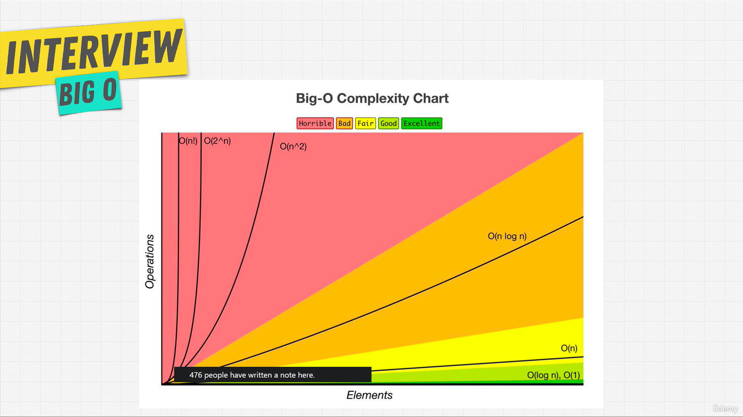

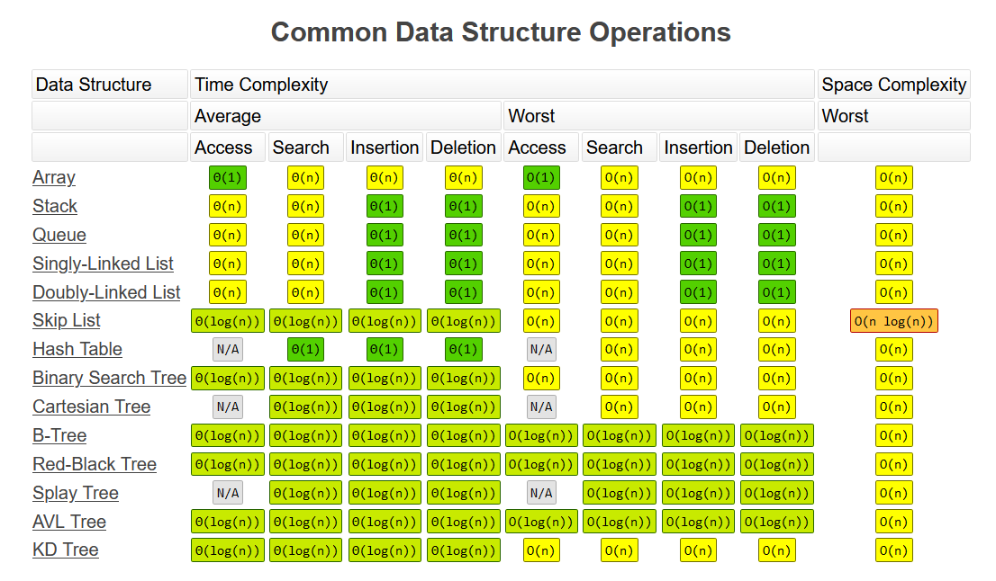

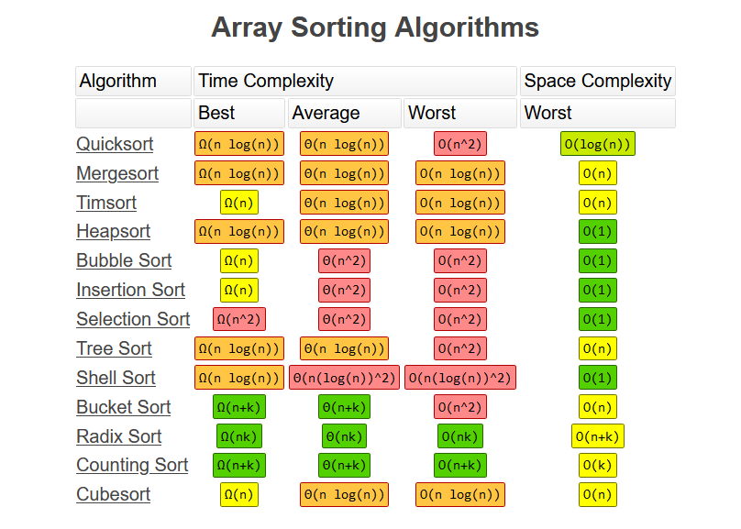

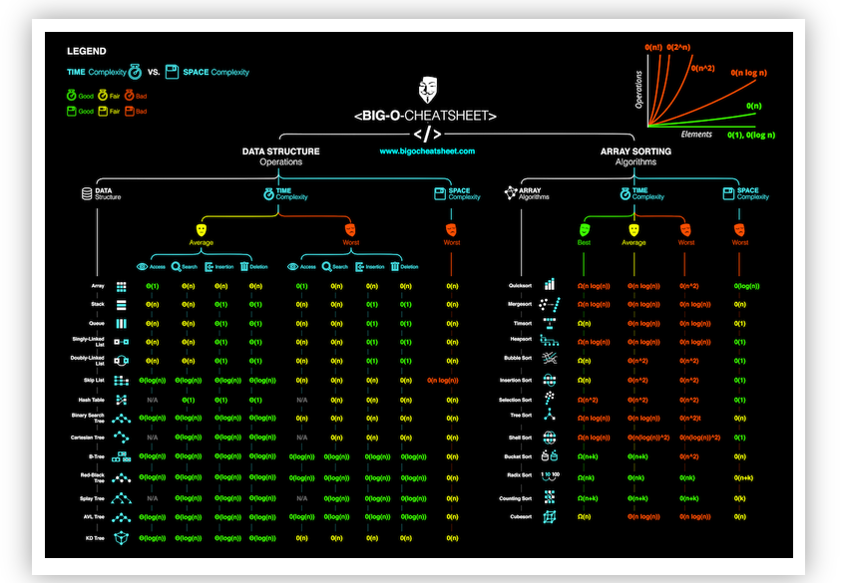

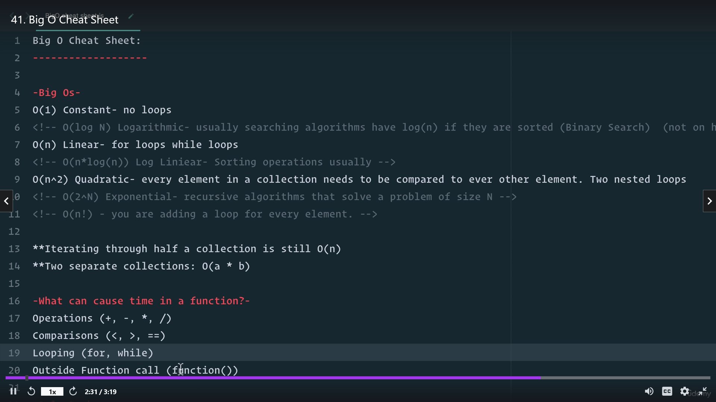

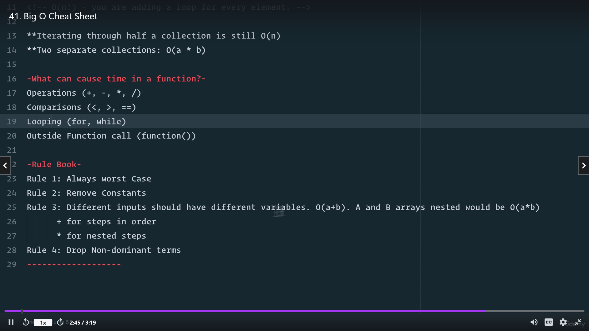

## Liner time -== O(n) == good

* Loops is linear time == o(n)

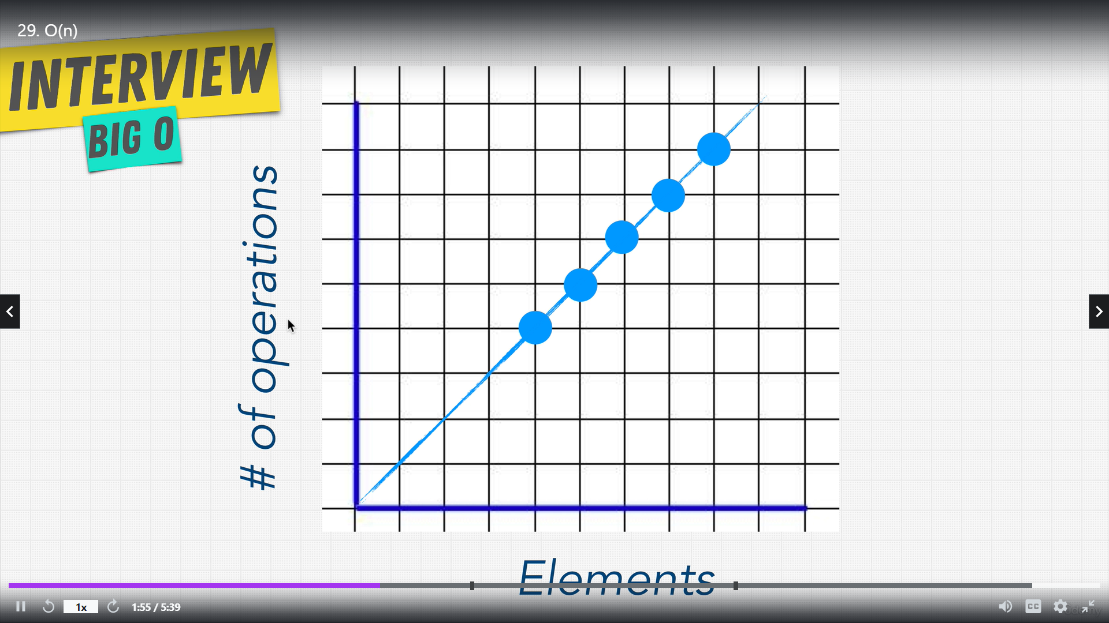

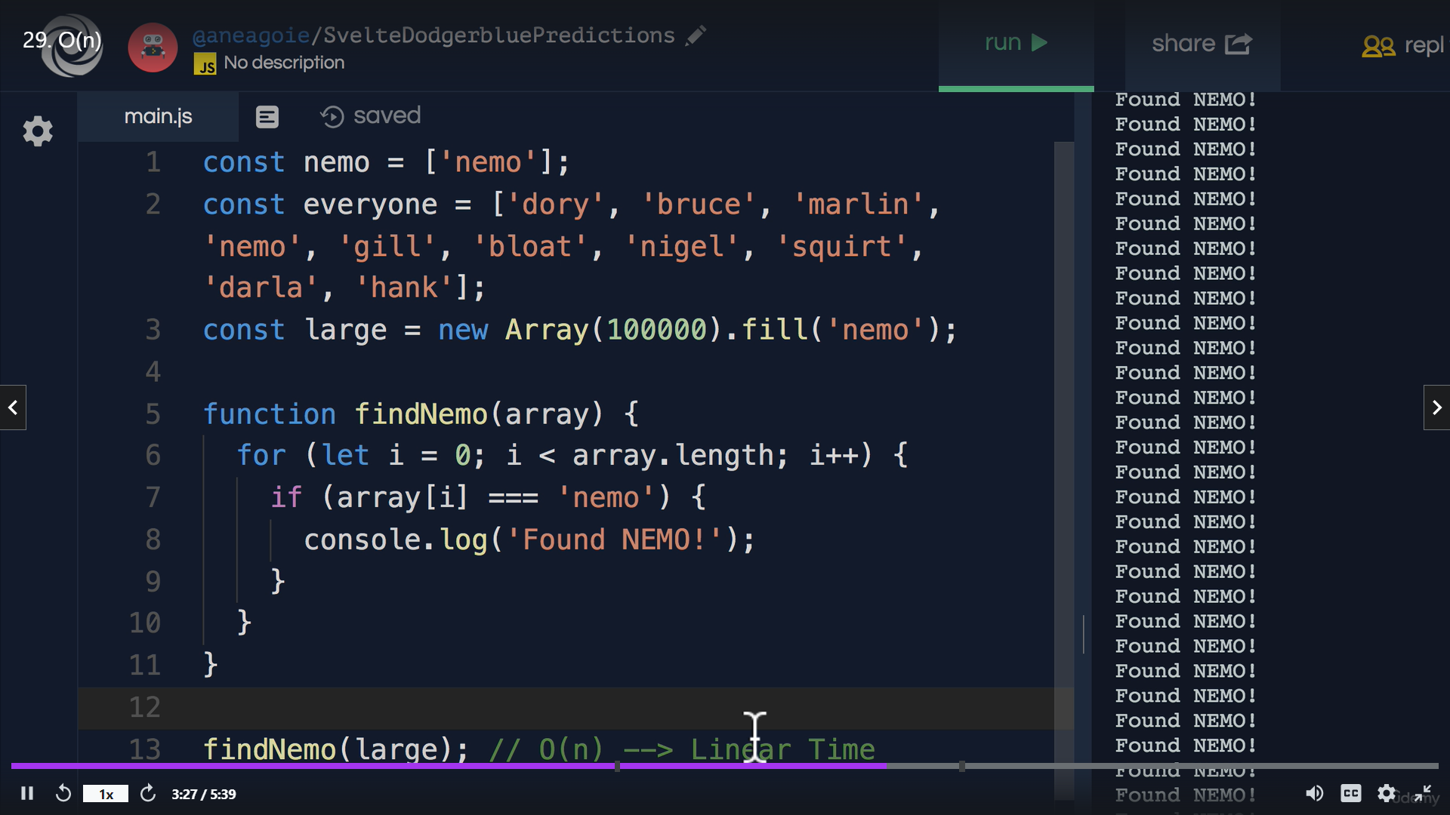

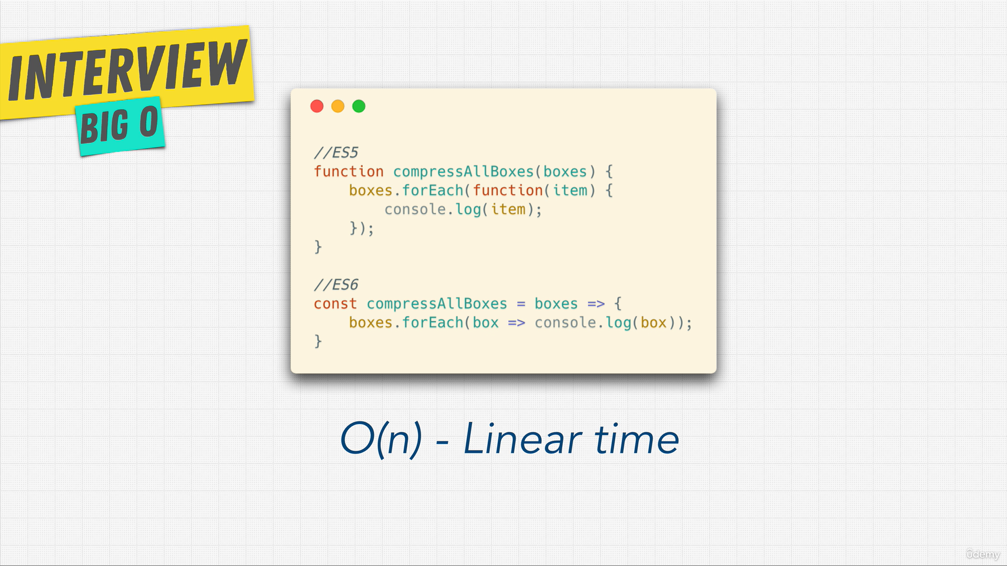

## Constant time -== O(1) == excellent

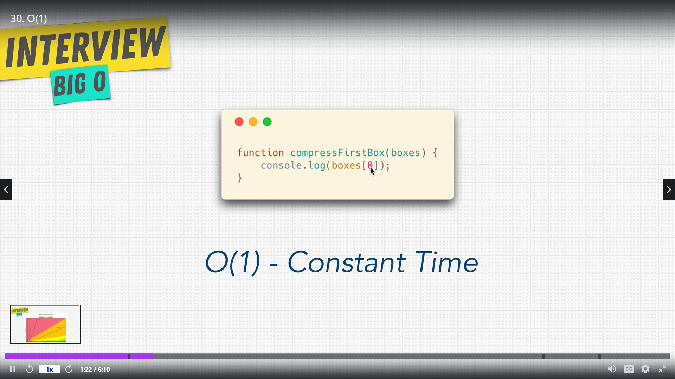

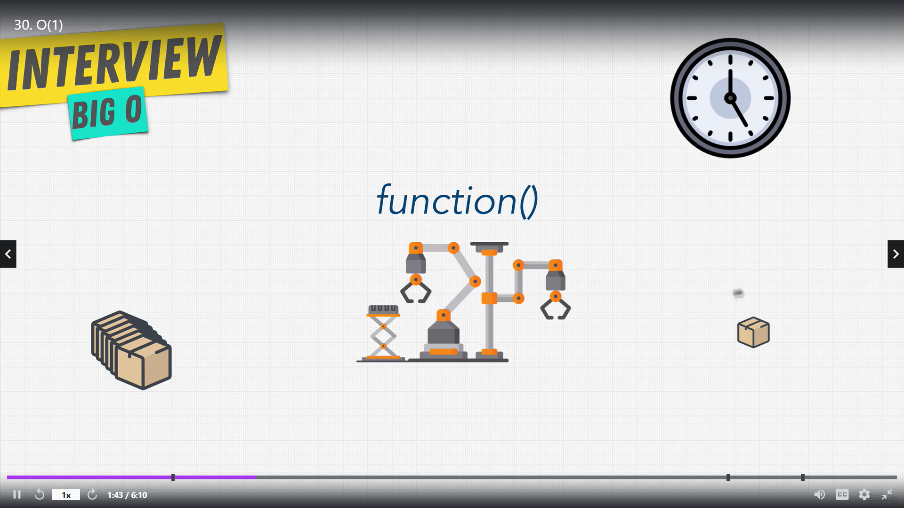

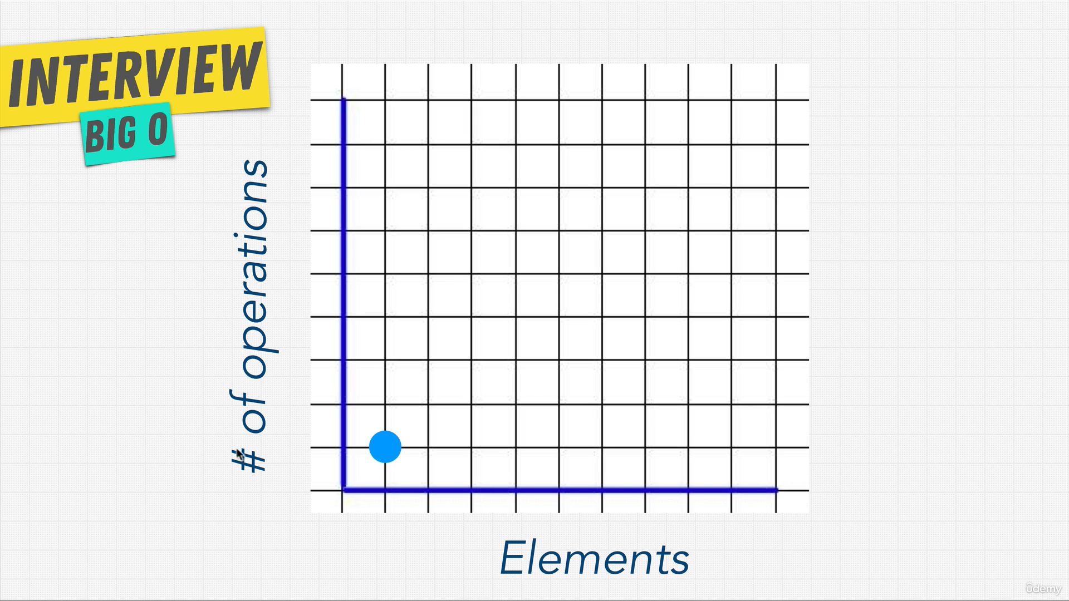

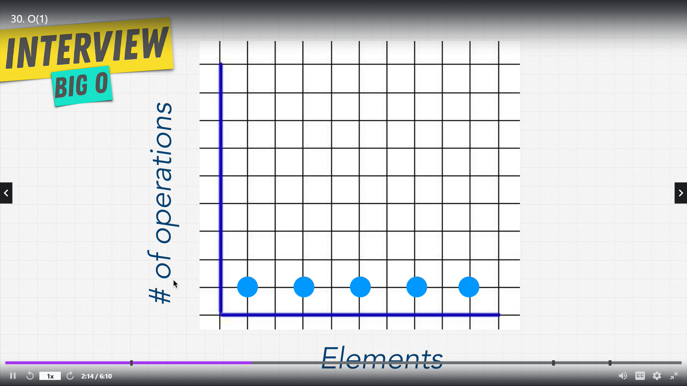

## Example

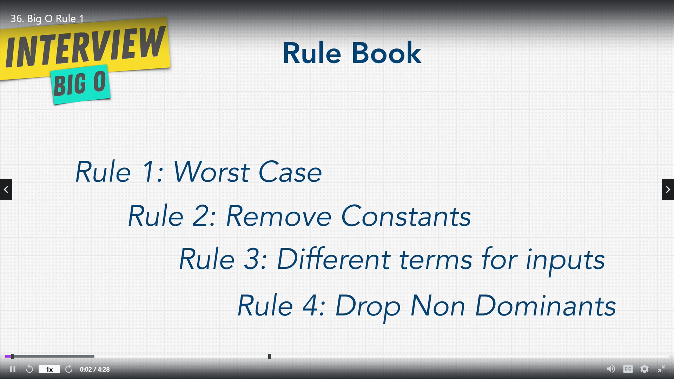

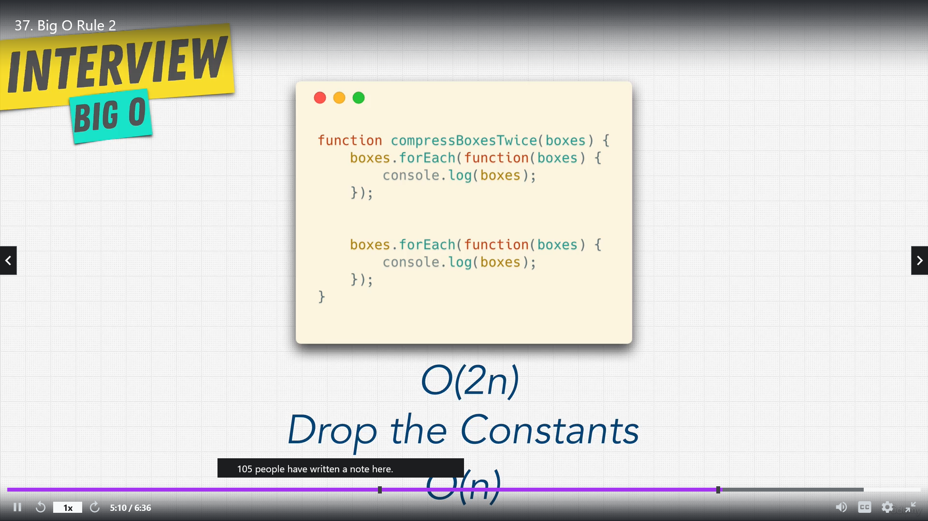

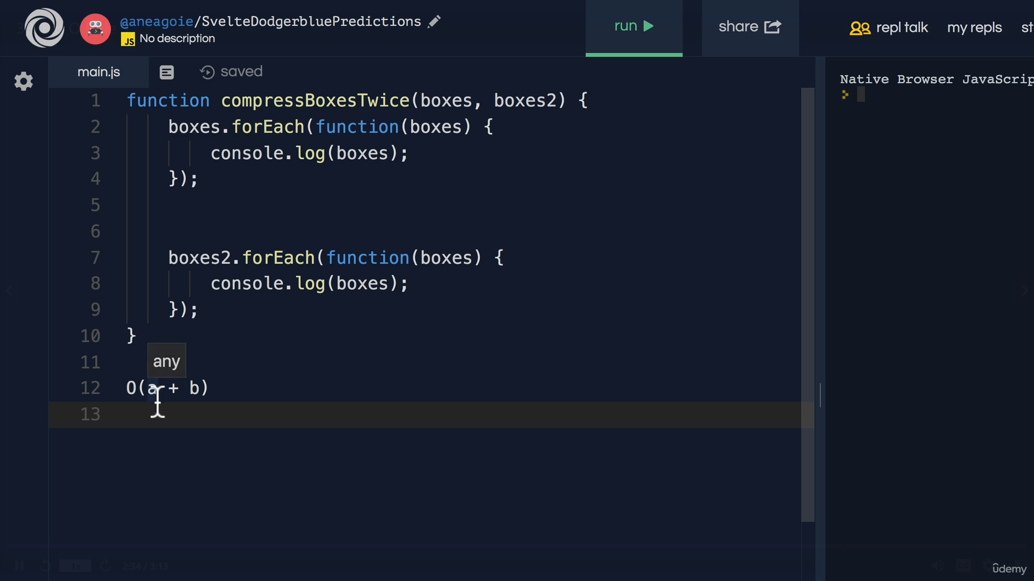

## Quadric Time O(n2) == For loop inside for loop

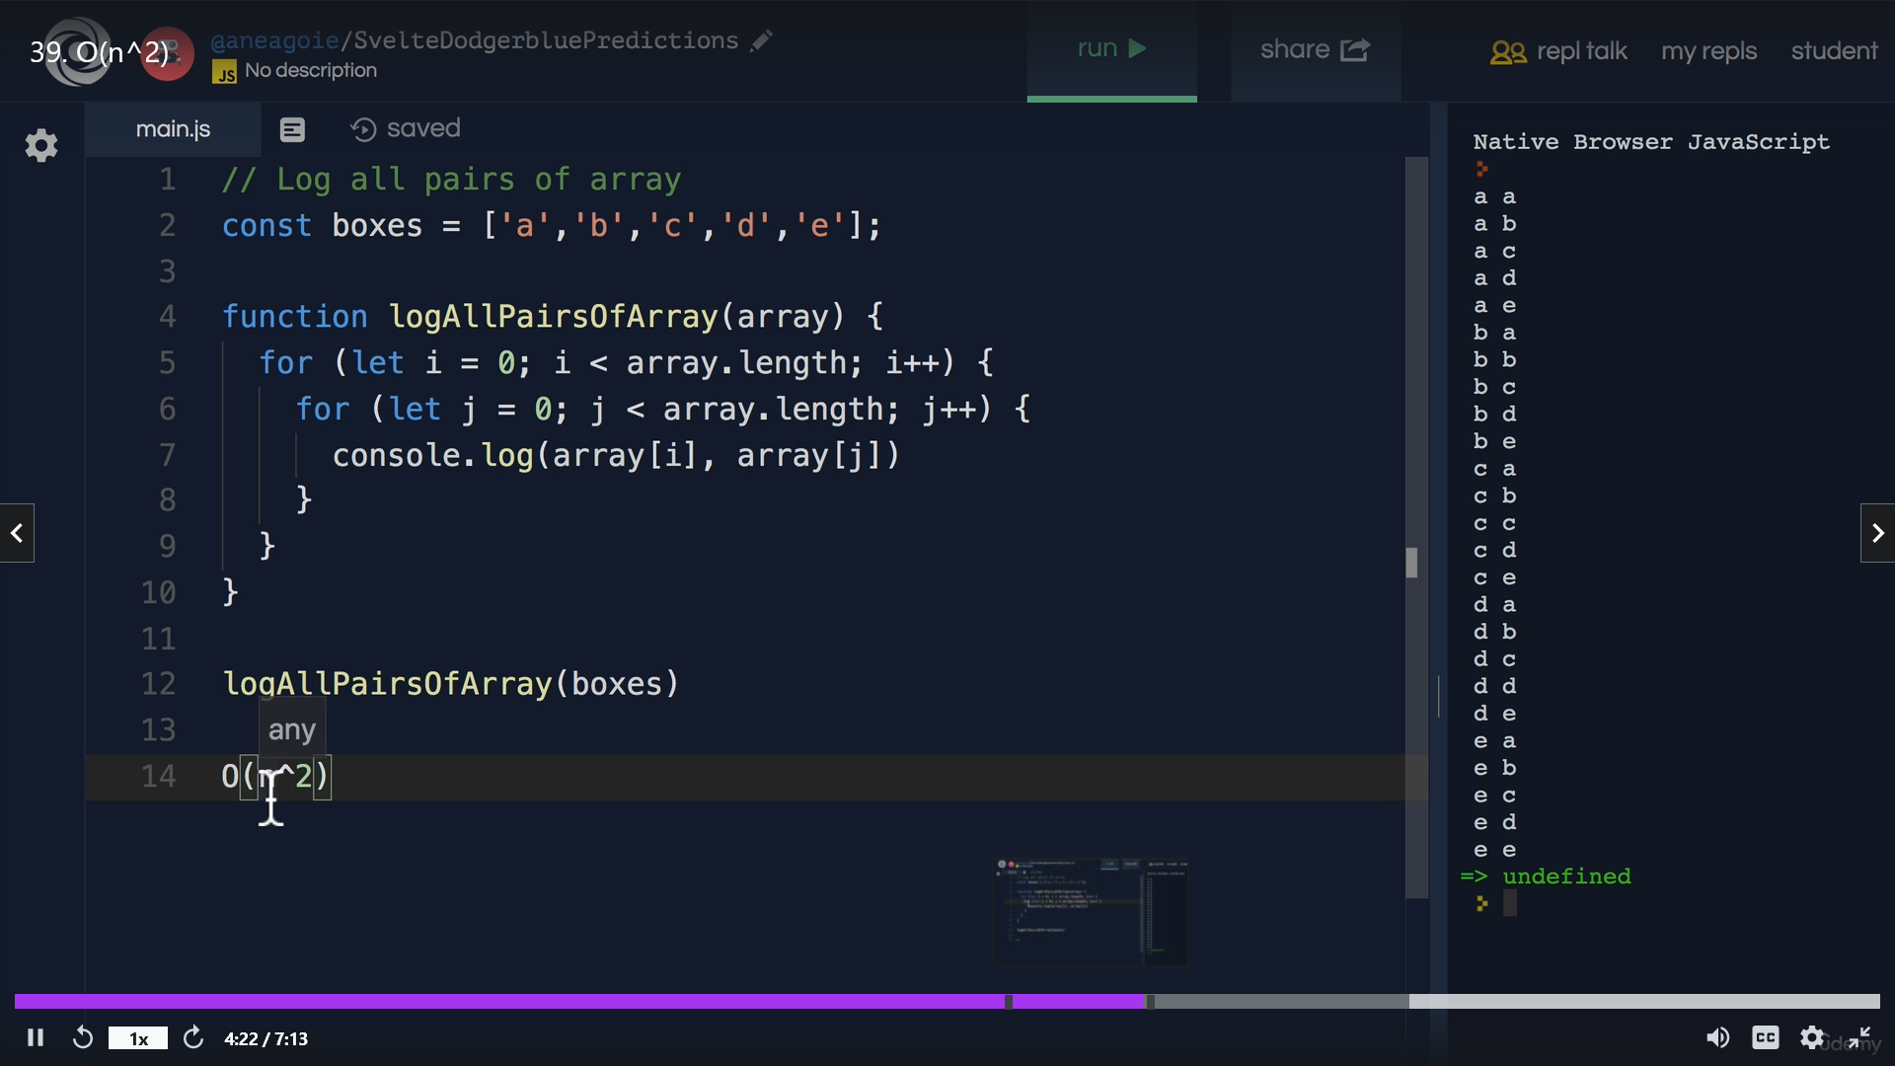

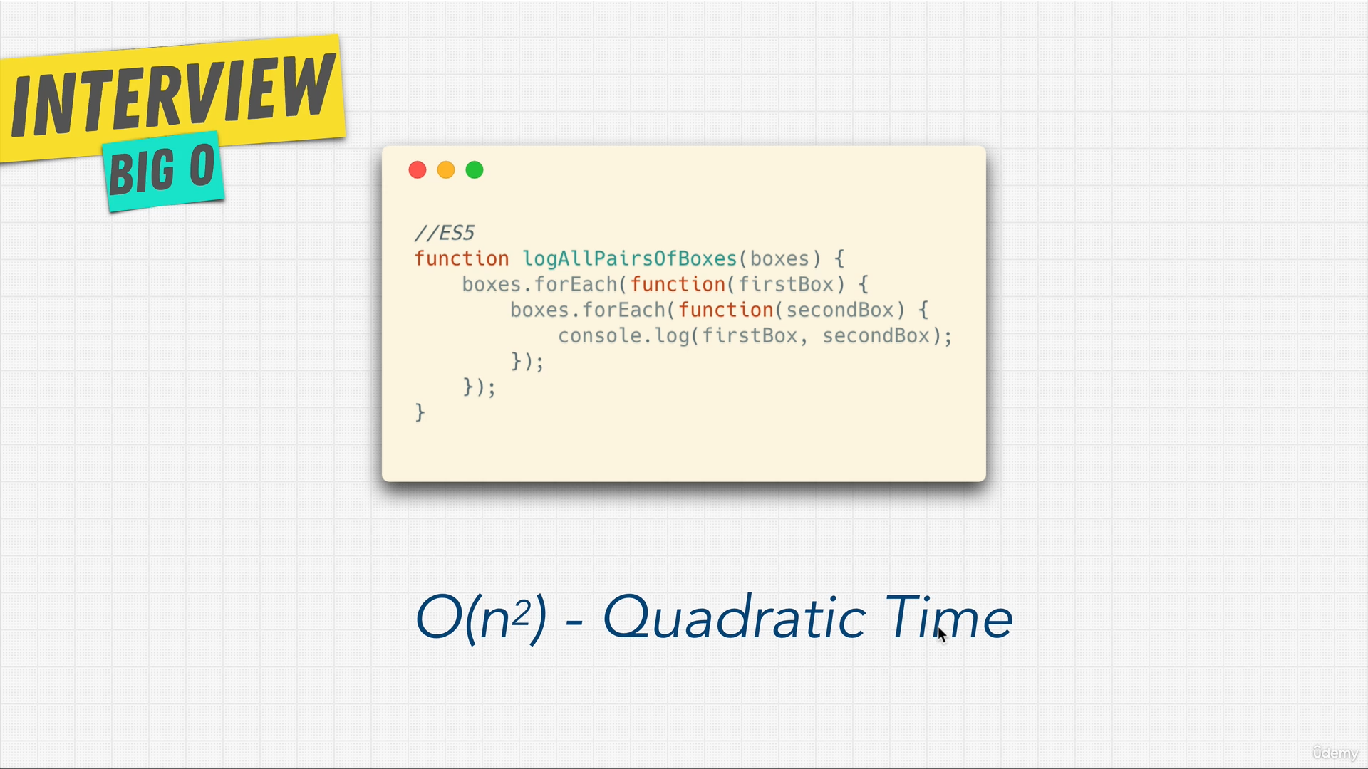

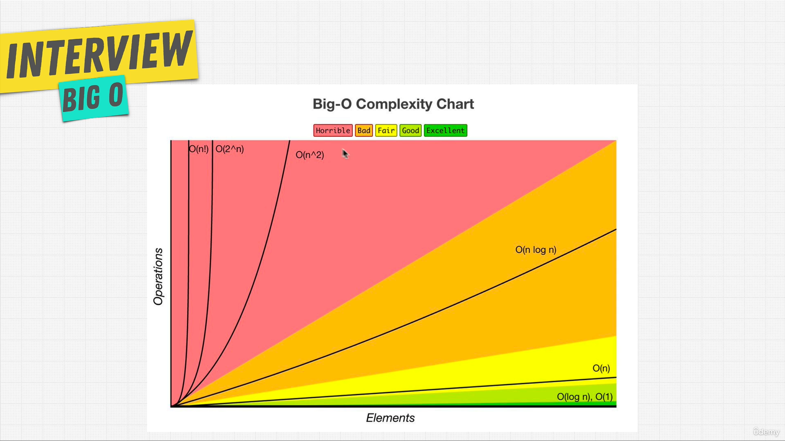

Binary search

# <https://www.crackingthecodinginterview.com/contents.html>

* Arrays and Strings
* Linked Lists
* Stacks and Queues
* Trees and Graphs
* Bit Manipulation
* Math and Logic Puzzles
* Object-Oriented Design
* Recursion and Dynamic Programming
* Sorting and Searching
* Scalability and Memory Limits
* Testing
* C and C++
* Java
* Databases
* Threads and Locks
* Assorted Moderate Problems
* Assorted Hard Problems

# GeekForGeek

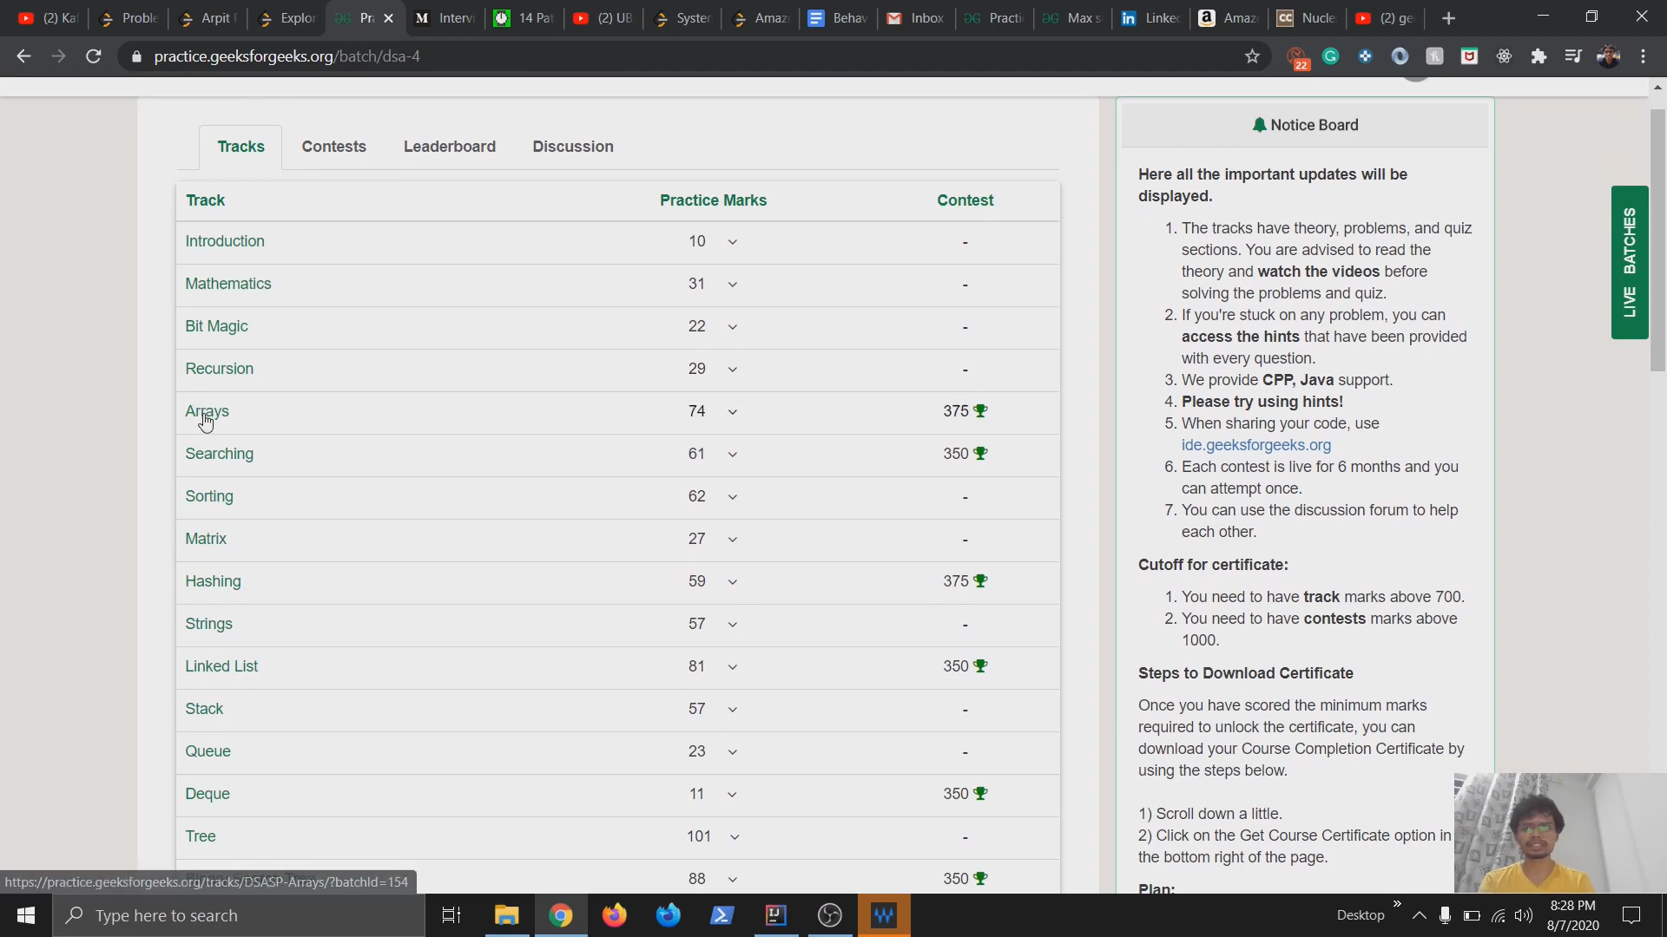

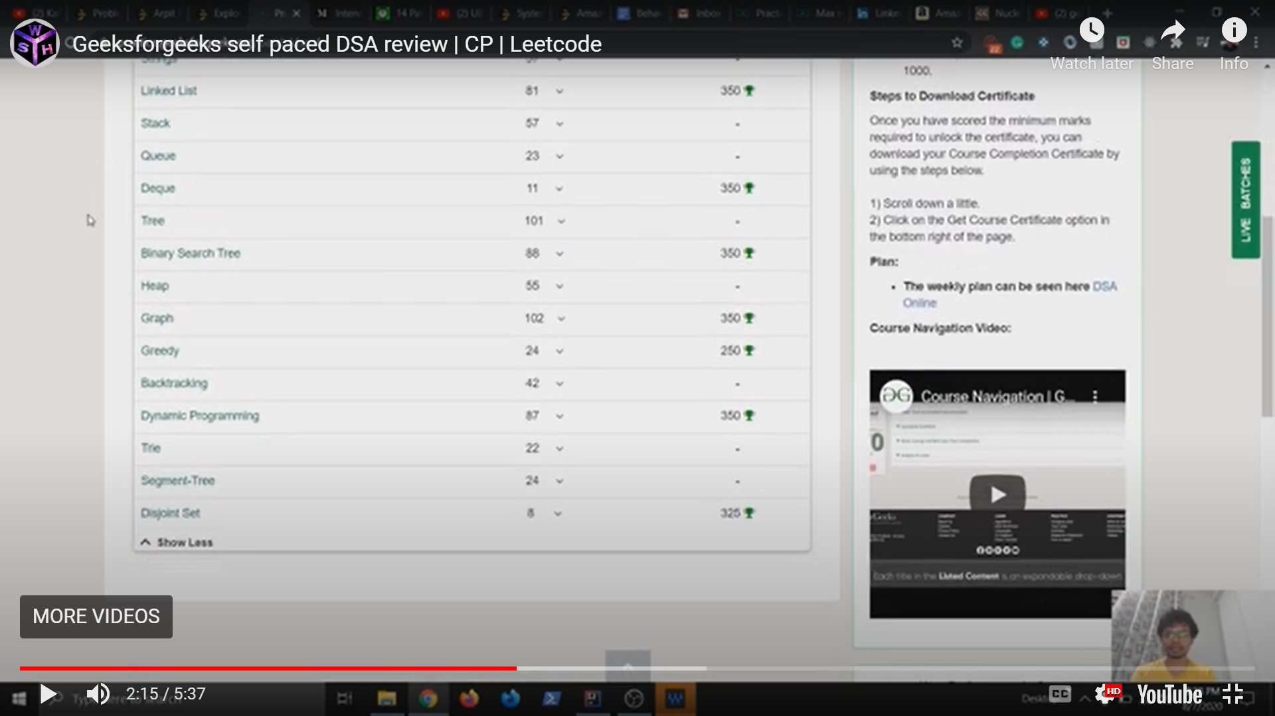

# logicmojo syllabus

